To purchase activities from your School District’s Online School Payments (OSP) site:
- Navigate to the Online School Payments website from any Web browser. (Be sure to bookmark this page!)
Tip: For Fulton County Public Schools use: http://osp.osmsinc.com/fultonga
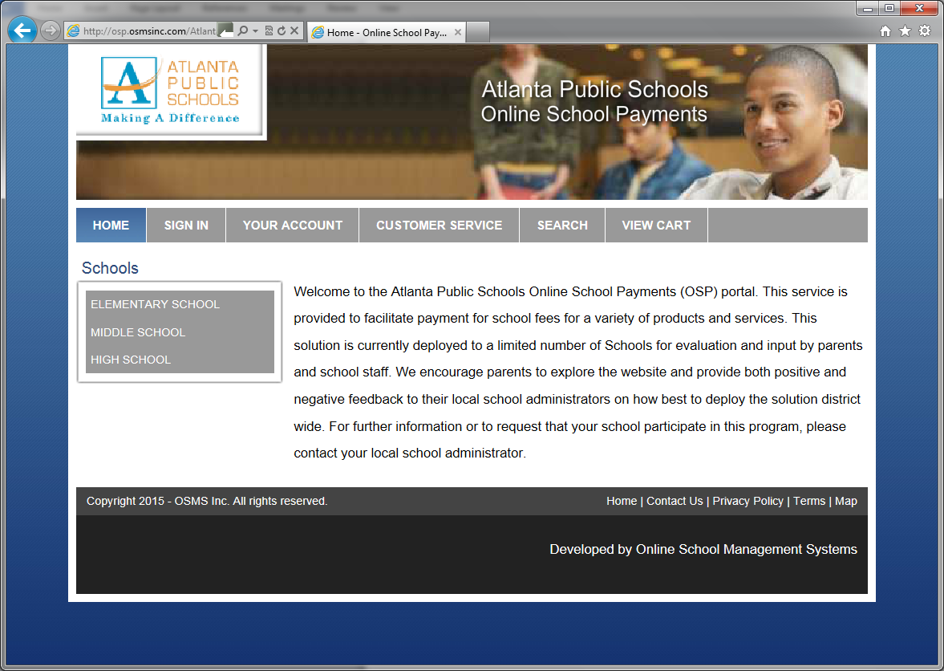
- Locate your school from the categories on the left side of the page.
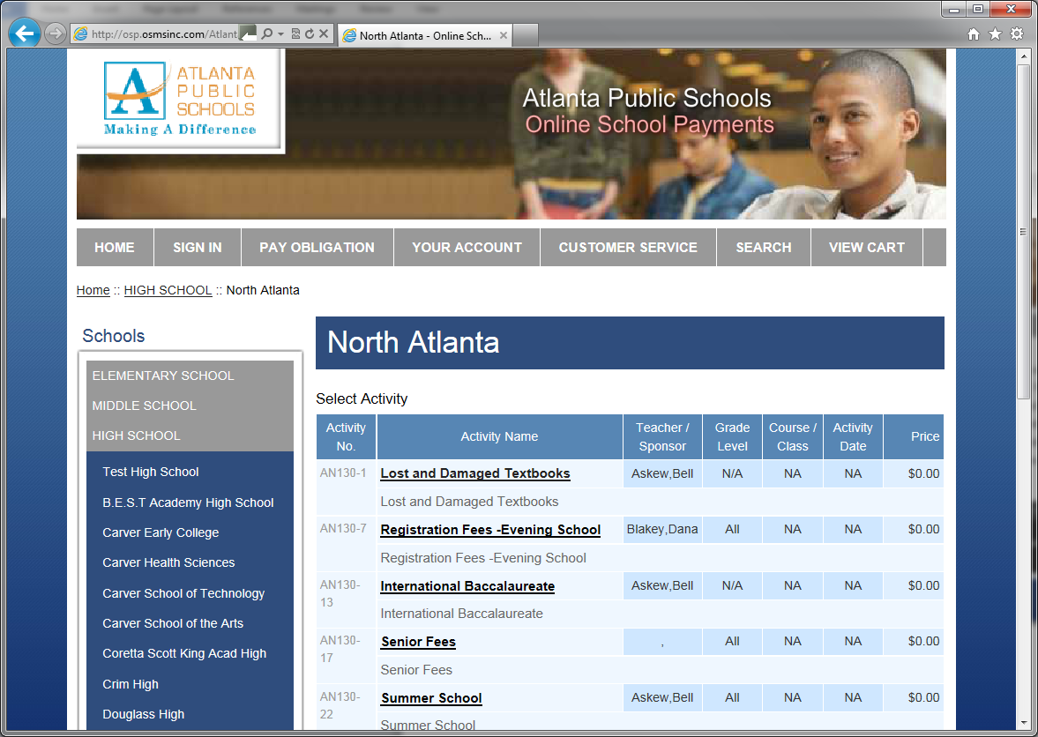

- Select any activities you wish to purchase by clicking on the Activity Name.
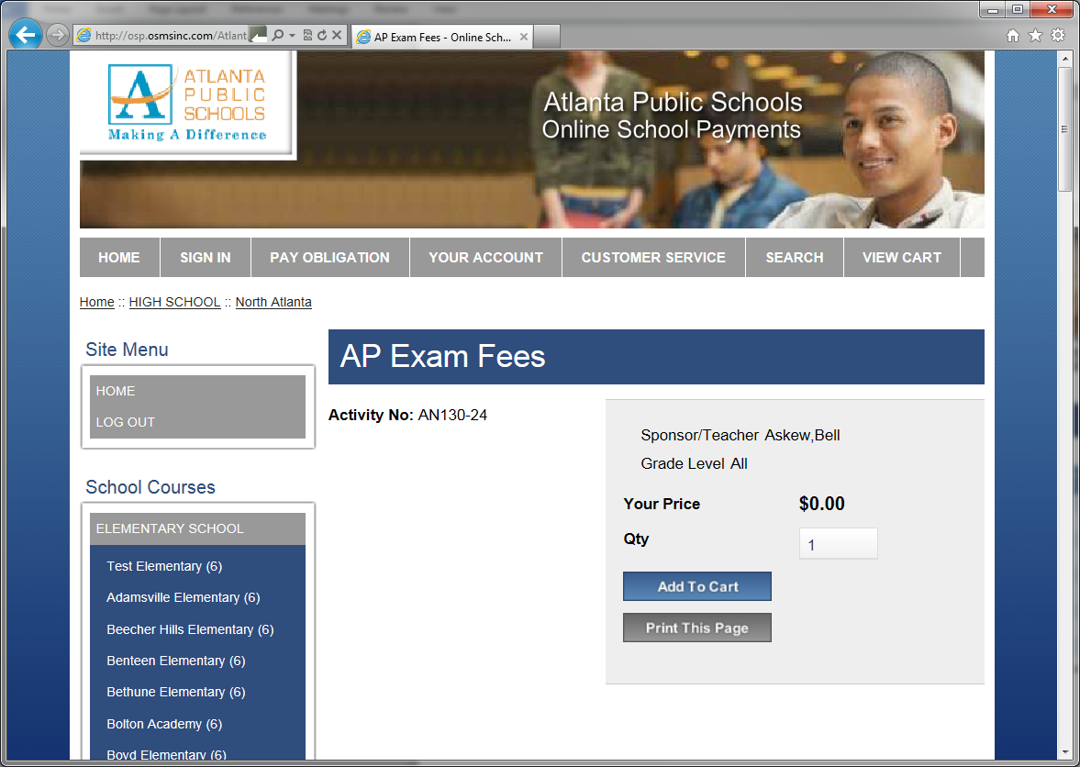
- Click Add to Cart to add this activity to your shopping cart.
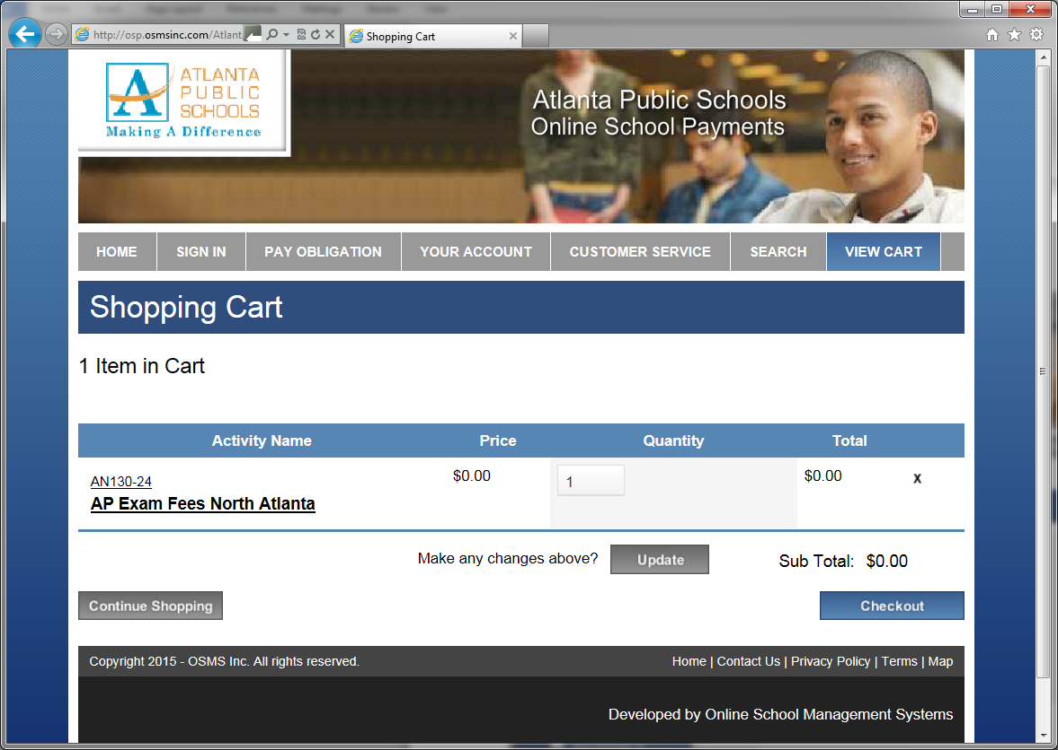
- Here you may Continue shopping to add additional activities (return to step 3) or press the Checkout button to complete the payment.
- You will now be asked to login if a returning user or create an account if you are a new user.
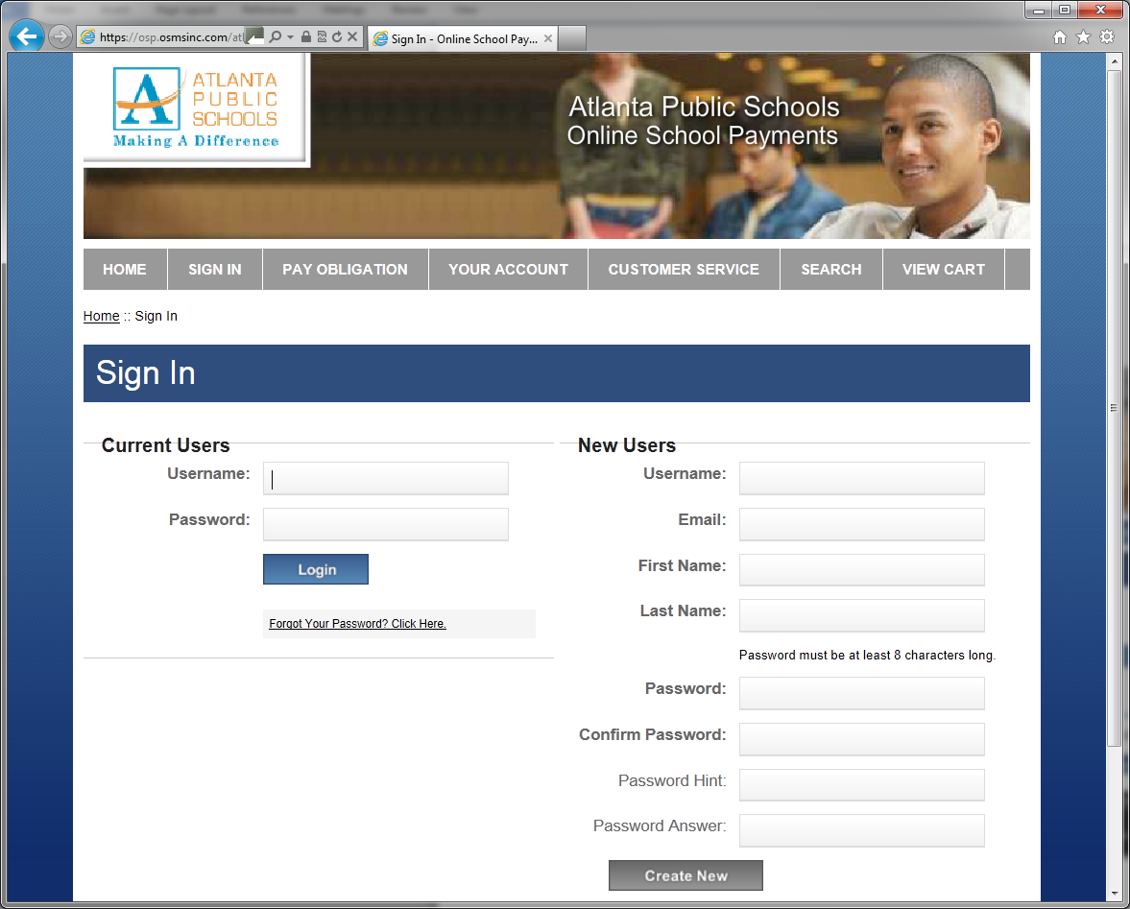
- Next you will be asked to assign a student to each activity in your cart.
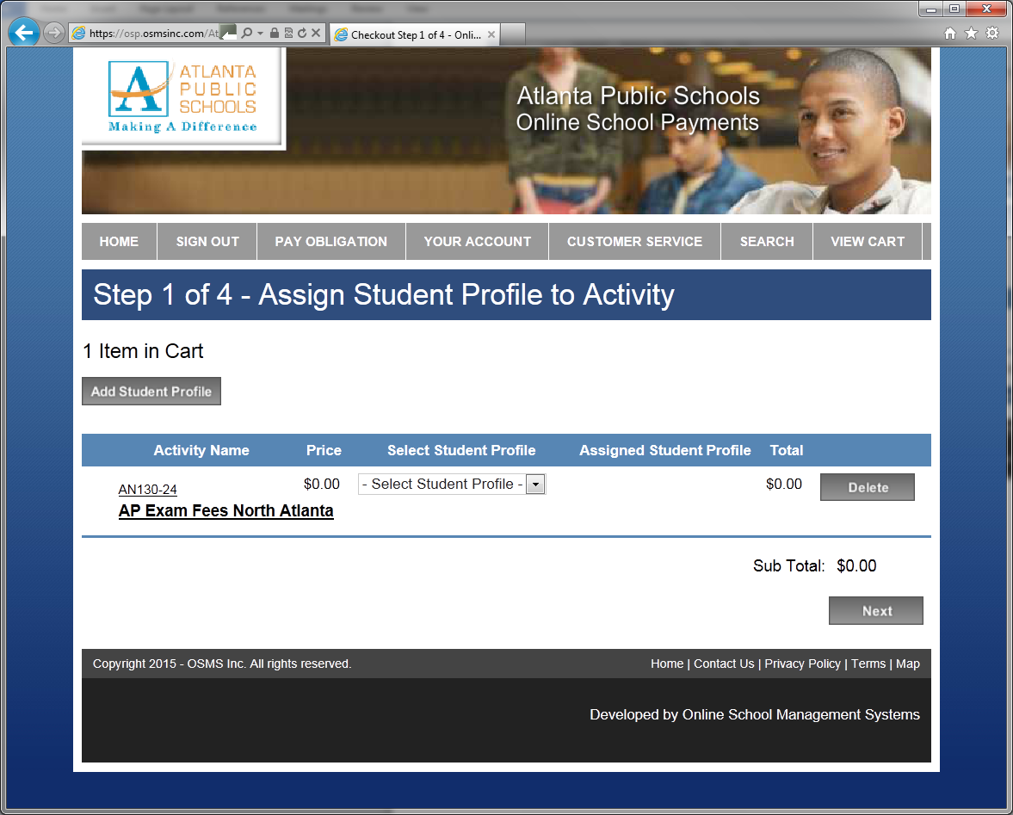
- If your student has already been added to the system, select their name from the Select Student Profile list box. Otherwise, click on the Add Student Profile button to add a new student, enter their information and press the Save Changes button.
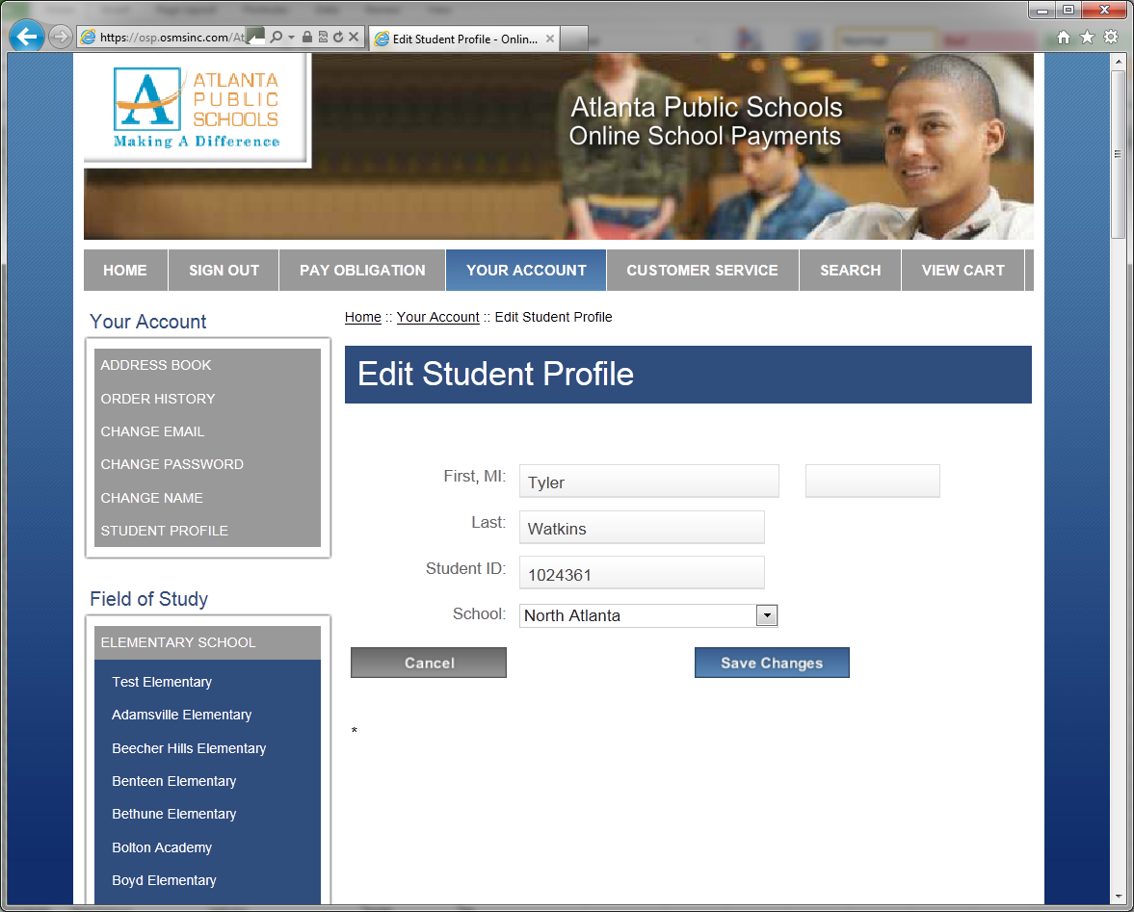
- OSP returns to the assign student screen where you can now select the student to assign to the activity and press the Next button.
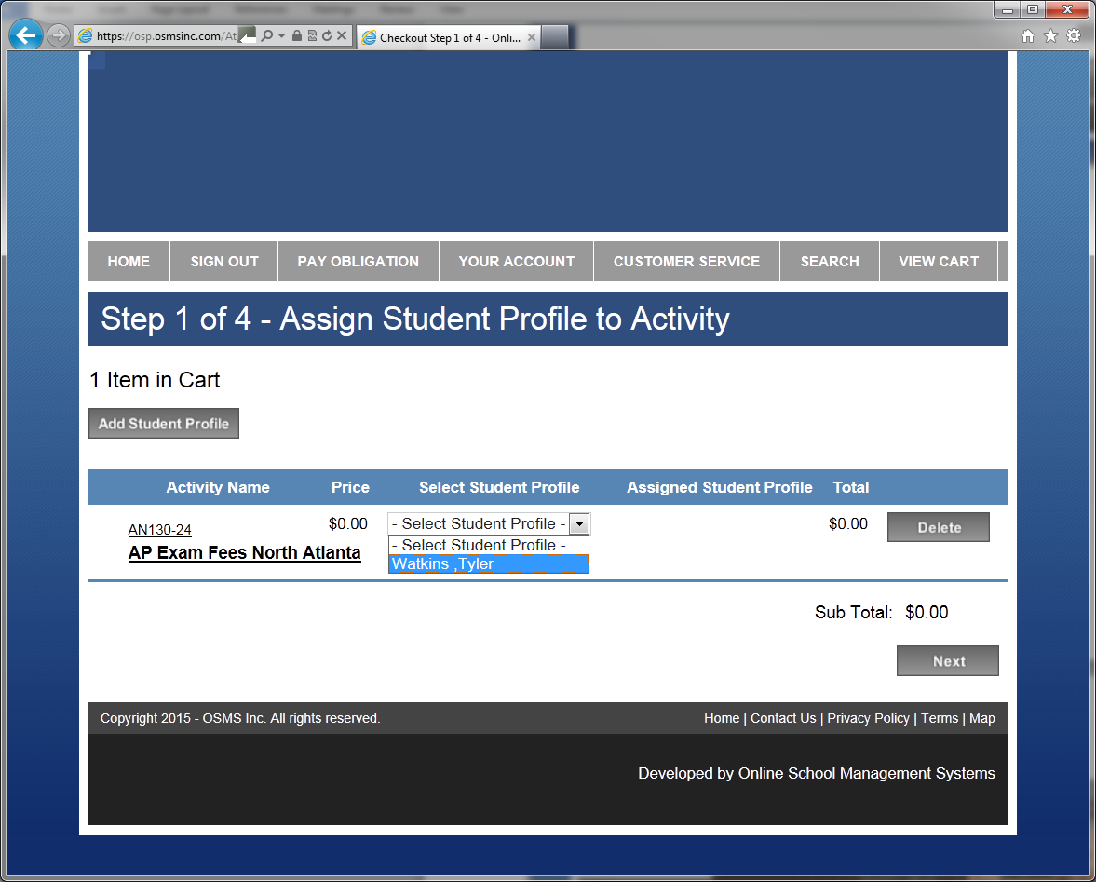
- Next enter your address that will match the billing information you intend to use for payment and press the Next button to proceed.
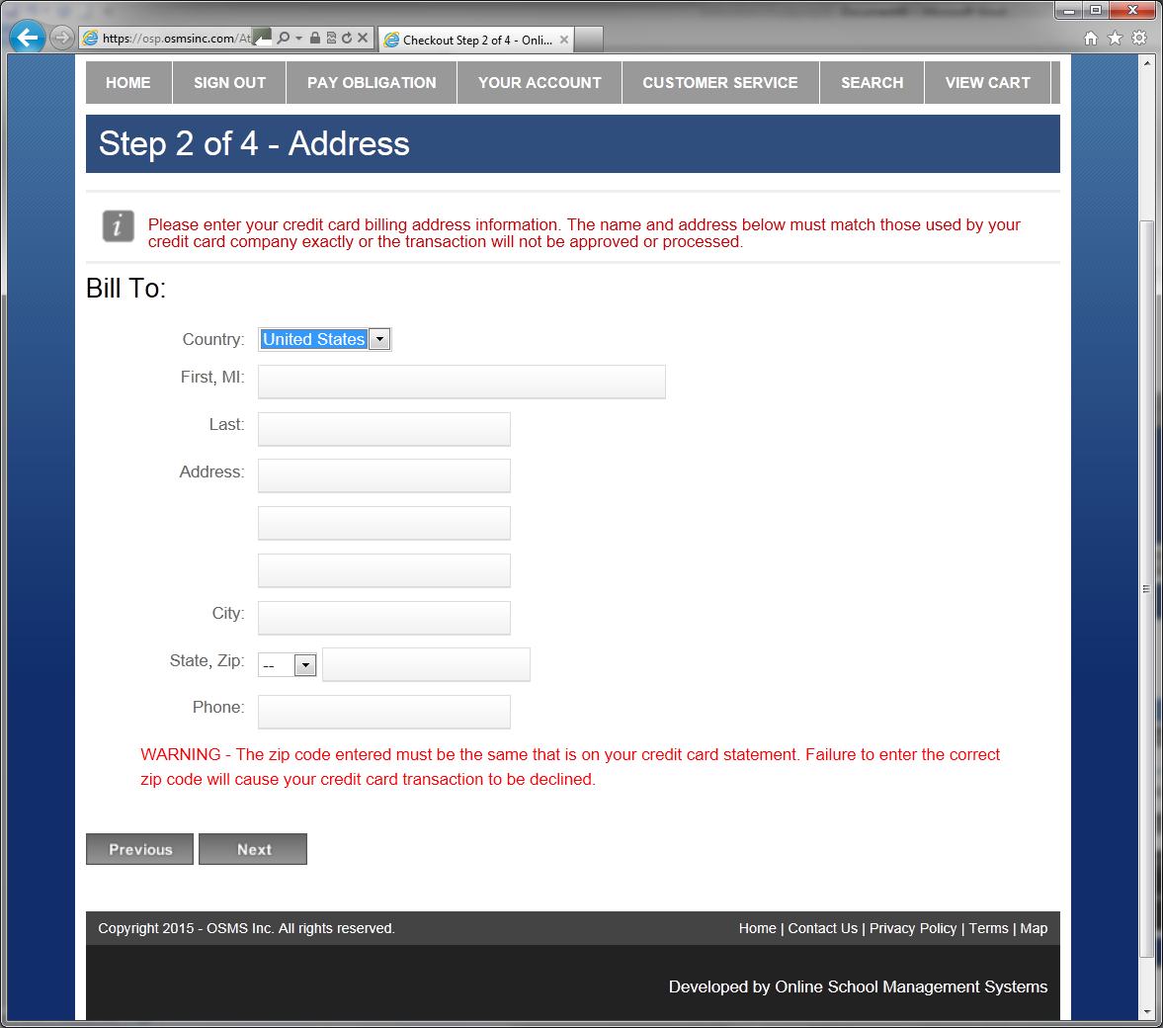
- Enter your card information and click the Review Order button.
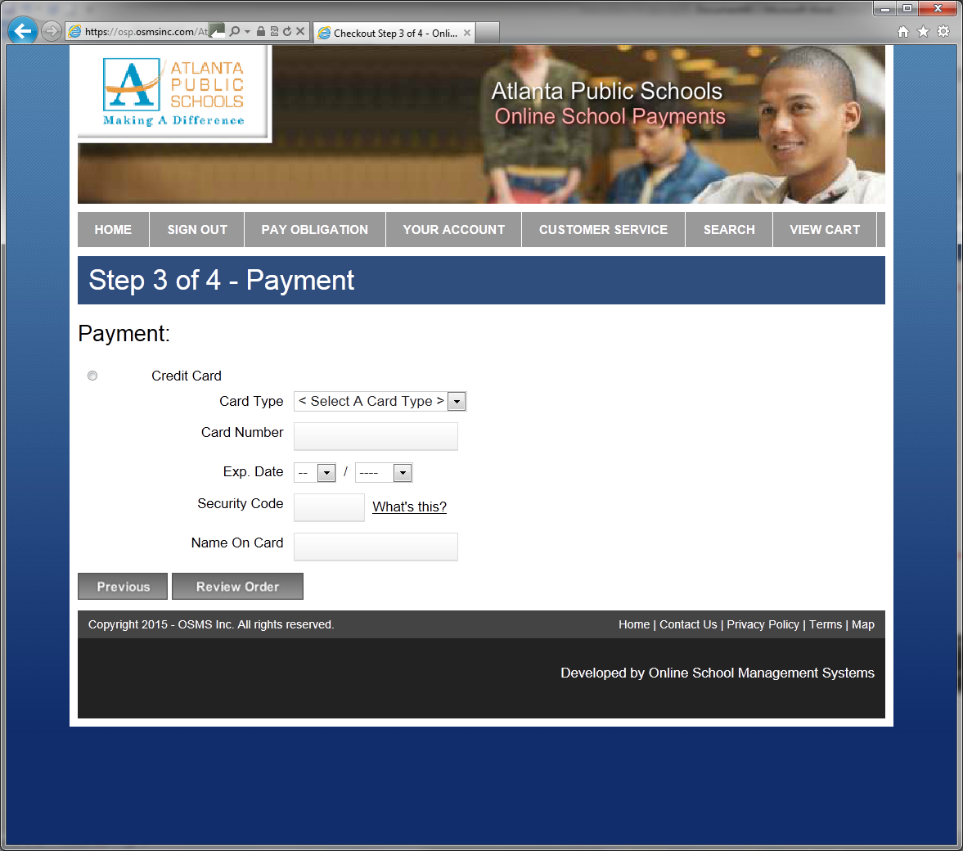
- Review your order and click the Place Order button to submit your order.
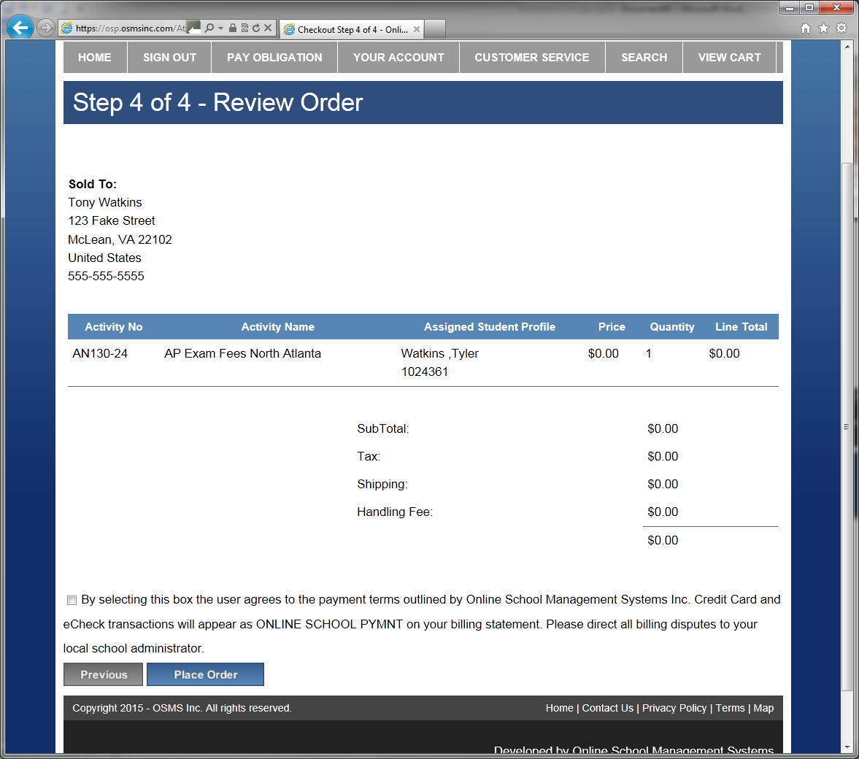
- Once the transaction is complete, OSP displays a Thank You message with the Order Number for this transaction.
A receipt is also sent to your email address and is always stored in your OSP account under the Your Account tab.
